**Optimization of a Reactive Distillation process for the synthesis of Dimethyle Carnonate**

**Summary of the Project:** Dimethyl carbonate (DMC) is an environmentally benign, biodegradable, and versatile chemical used as a green substitute in methylation and carbonylation reactions. It also serves as a fuel additive due to its high oxygen content and octane number. Conventional synthesis routes like urea methanolysis suffer from low selectivity and high methanol requirements. Direct synthesis from propylene carbonate (PC) and methanol faces equilibrium limitations but can be enhanced by reactive distillation. However, DMC forms an azeotrope with methanol, making downstream separation a key challenge. Various separation methods exist, but pressure swing distillation stands out as effective and eco-friendly. Energy demand increases due to excess methanol usage, requiring efficient process integration. This project focuses on optimizing reactive distillation with integrated separation to minimize cost.

**Reaction Kinetic and Thermodynamic Model:**

**Reaction Kinetic:** The transesterification of PC with MeOH, using homogeneous catalysts, has already been investigated. Even though many catalysts are suitable for this reaction, sodium methoxide is still a promising candidate in the current industrial application since it possesses higher activity compared with other catalysts. Moreover, its reaction temperature is relatively mild. The liquid-phase reversible transesterification reaction considered is.

PC + 2MeOH ↔ DMC + PG

The kinetics for the forward and reverse reaction catalyzed by sodium methoxide.

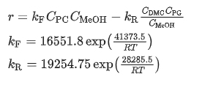

* Where r is the reaction rate of PC (mol.L-1.min-1)
* Ci is the concentration of the ith component (mol.L-1)
* R is gas constant (J.mol-1.K-1)
* T is temperature (k)

**Thermodynamic model**

The phase equilibrium of this reaction system is complex due to the existence of a binary azeotrope mixture of DMC and MeOH. In order to accurately describe the phase equilibriums of the system, UNIQUAC model is used, and its parameters are obtained to fit the vapor–liquid data. The experimental data for the pair of MeOH/DMC were obtained from literatures. The vapor–liquid equilibrium data for the pairs of DMC/PC and DMC/PG were obtained from literature. The model parameters of MEOH/PG and all other physical properties were obtained directly from DWSIM., which indicates that the UNIQUAC model is suitable for this system.

**Steady-state Optimization**

**Reactive distillation process:** The process for the production of DMC by reactive distillation is shown in Fig.1. In this flowsheet, the reactant PC (stream F1) is fed into the top part of the reaction section, and the fresh MeOH (stream F2) and a recycled stream rich in MeOH are fed into the bottom and middle of the reaction section, respectively. The top product of the reactive distillation (RD) column is a mixture of product DMC and un-reacted MeOH, while co-product propylene glycol leaves out the bottom of the RD column. The distillate of the RD column is fed into the high pressure (HP) column, which produces high-purity DMC in the bottoms and a distillate stream whose composition is near that of the azeotrope. The distillate (stream R1) is recycled back to the RD column. Due to the very low catalyst concentration (about 0.15 wt%), the catalyst component was ignored in the simulation for simplification.

The results indicate that the proposed process is feasible for the synthesis of DMC. However, the feed molar ratio of MeOH to PC (≈ 5.6:1) is much higher than that of stoichiometric ratio in the transesterification reaction and the PC conversion is not very high (about 96.5%), which means that more energy is required to further purify the co-product PG and recover excess methanol. Hence, in this study the feed molar ratio will be optimized while ensuring the desired PC conversion rate of 99.9% and the desired DMC purity of 99.5 mass%. Since the solubility of sodium methylate in the PC or PG is relatively low, sodium methylate is dissolved in the methanol firstly and then is introduced into the RD column with PC. To avoid clogging pipes or internals in the RD column due to the crystallization of the sodium methylate, the mass concentration of MeOH in the fresh PC feed is another constrain.

**Flowsheet convergence**: Because stream R1, containing MeOH and DMC, is recycled back to the RD column, it is not easy to estimate reasonable distillate flow rate for both the RD and HP columns. As we all know, when recycle streams are present, the convergence of steady-state simulators becomes very difficult. To ensure the convergence of the simulation, the distillate of the RD column and the HP column must be estimated in advance. In order to solve such a complicated matter, therefore, a simple and effective method based on the mass balance is proposed.

For the RD column, DMC leaving the RD column is the sum of the DMC formed in the transesterification reaction *R*DMC and the DMC in the recycle stream *D*2, DMC.



The MeOH mass flow rate in the stream D1 is calculated by:



where *m*1 is the mass composition of MeOH in the azeotropic mixture (DMC and MeOH) under the atmospheric pressure.

According to the purity of the product DMC, the amount of MeOH in the distillate of the HP column, *D*2, MeOH, is estimated by

In the same way, *D*2, DMC is estimated by

where *m*2 is the mass composition of MeOH in the recycle stream.

Thus, the procedure to estimate the flow rate of the recycle stream between the RD and HP columns is described as follows:

* Give the mass composition of MeOH in the recycle stream (*m*2) and suppose *D*2, DMC is equal to 0.
* The amount of DMC in the distillate of the RD column is computed
* The amount of MeOH in the distillate of the RD column is calculated
* The mass flow rate of the recycle stream is calculated
* Go back to the step 2, repeat steps (2)–(4) until the calculated values (*D*2, DMC or *D*2, MeOH) remain unchanged.

Once the values of *D*1, DMC, *D*2, DMC, *D*2, DMC, and *D*2, MeOH are determined, the distillates of the RD column and the HP column (*D*1 and *D*2) are easy to be obtained.

**Optimization:** By using above iterative optimization procedure, the values of the design variables were found feed location of the RD column, total stages of the RD column, feed location of the HP column, and total stages of the HP column. Because the overhead vapor at the top of the HP column can be used as the heat source of the reboiler of the RD column, the TAC of the RD column does not include energy cost and reboiler cost and thus is significantly lower than the TAC of the HP column. The resulting optimal flowsheet with flow and composition , shows component generation amounts profile in the RD column, and the corresponding temperature and vapor composition profiles are presented in [Fig. 6](https://www.sciencedirect.com/science/article/pii/S1004954116310357" \l "f0030). Note that the feed molar ratio of MeOH to PC is 2.61:1 and close to stoichiometric ratio in the transesterification reaction. The conversion ofPC under optimal conditions reached as high as 99.9% and energy saving of 18.6%.

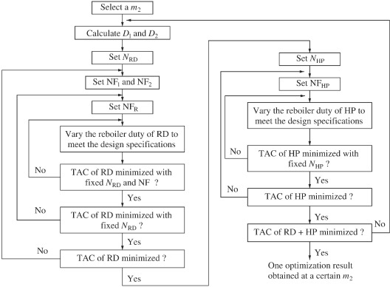

**RD column 1**

**

**HP Column costing**

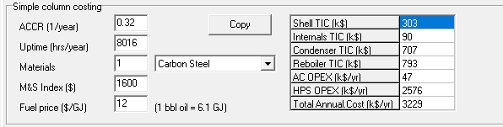

**Liquid composition and Temperature profile in the RD column**

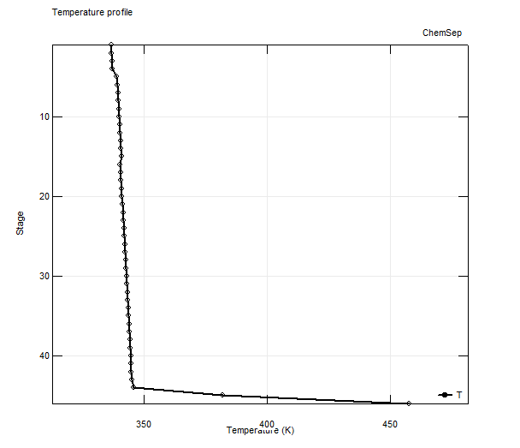

**Conversion generation profile in the RD column**

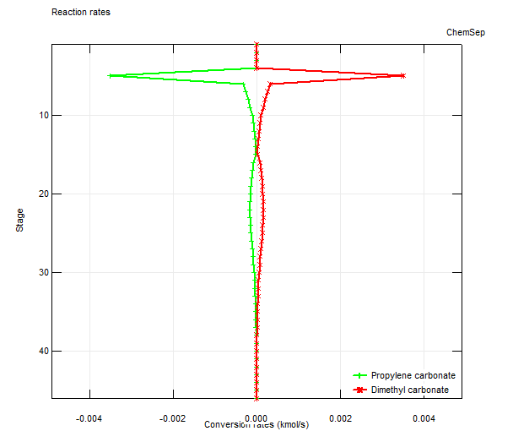

**HP column:**

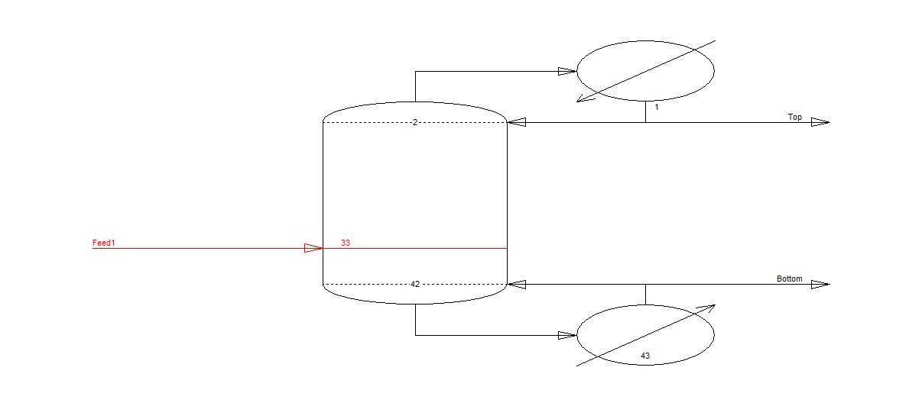

**Liquid composition and Temperature profile in the HP column**

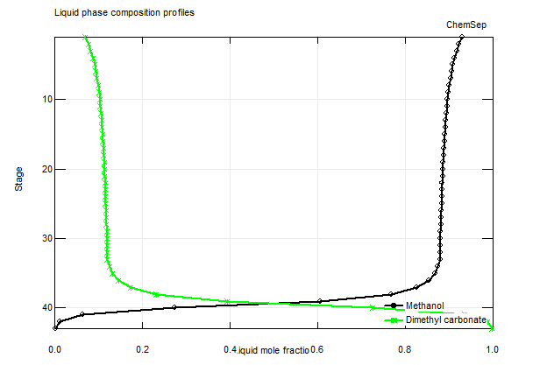

**Conclusion:**

Dimethyl carbonate is an environmentally benign and biodegradable chemical. A novel process including a RD column with an excess of reactant MeOH and a high-pressure distillation column is used to obtain high PC reaction conversion and high purity dimethyl carbonate product. The optimal process is determined by minimizing the total TAC. To estimate the flow rate and composition of the recycle stream in a pressure-swing distillation system, a simple and effective method is proposed and adopted in the process optimization. The optimization results show that the feed molar ratio of MeOH to PC is 2.61:1 and close to stoichiometric ratio in the transesterification reaction, and the modification process can save energy consumption by 18.6% with the propylene carbonate conversion of 99.9%.